Mount Saint Mary College
Newburgh, NY
Division of Education
Brandi Ripa
PSY 3700
Dr. Miller Spring 2011

Goal:
The students will master the prewriting step of the POWER writing strategy for comparing and contrasting expository and narrative texts.

Objective:
Given two reading passages (narrative or expository), in a book or on a handout, read to or by the student, and the directions, “Complete the graphic organizer to compare and contrast two items (characters, concepts, lessons, ideas, conflicts, or settings),” the students will complete steps 1-5 of the prewriting strategy listed on the poster, without prompts for five consecutive trials, using different reading passages for each trial.

Learning Standards
New York State English Language Arts Learning Standards
Grade 4 Reading
Standard 1: Students will read, write, listen, and speak for information and understanding.
- Compare and contrast information on one topic from two different sources.
- Use graphic organizers to record significant details from informational texts.
Standard 2: Students will read, write, listen, and speak for literary response and expression.
- Use graphic organizers to record significant details about characters and events in stories.
Background Knowledge and Vocabulary Development
The reading competencies common to all four ELA standards that students demonstrate during grade 8 are:
- Determine the meaning of unfamiliar words, terms, and idioms by using context, dictionaries, glossaries, and other print and electronic resources.
Standard 3: Students will read, write, listen, and speak for critical analysis and evaluation.
- Compare and contrast characters, plot, and setting in literary works.

Grade 4 Writing
Standard 1: Students will read, write, listen, and speak for information and understanding.
- Use organizational patters such as a compare/contrast, cause/effect, and time/order, for expository writing.
- Compare and contrast ideas and information from two sources.
Standard 2: Students will read, write, listen, and speak for literary response and expression.
- Write interpretive and responsive essays that:
  - Describe literary elements such as plot, setting, and characters
  - Describe themes of literary text
  - Compare and contrast elements of texts
- Produce clear, well-organized responses to stories read or listened to, supporting the understanding of characters and events with details from the story.

National Council of Teachers of English Learning Standards
Standard 5 Students employ a wide range of strategies as they write and use different writing process elements appropriately to communicate with different audiences for a variety of purposes.

Prerequisites
- Given item and the directions “List four characteristics about this item,” students will write four characteristics about the given item.
Examples:
a. Sarah: a girl, long hair, in 4th grade, has a dog.
b. Ocean: body of water, a habitat for animals, large, has pollution
- Given a two items and the directions “Compare these two items,” students will write characteristics the items have in common.
- Given a two items and the directions “Contrast these two items,” students will write characteristics not shared by the two items.
- Given a reading passage and the directions “Read the story, and summarize it,” students will write an accurate summary of the story.
Introduction
Tell the students that today they will be learning a strategy to help them organize their ideas whenever they have to compare and contrast reading passages. This strategy will be used before they write their final paper to ensure their ideas and sentences are clear, and they include details about how two items are alike and different. By the end of the lesson they will be able fill out a graphic organizer that will make the writing process easier. They need to know this because it will help them write good, quality compare and contrast essays for the upcoming ELA exams.
Day 1 Review: (Prerequisite #3) I will list two items on the board, and ask the students to list differences of these two items. They will have a minute to work and when they are done they can share their similarities with the class. If there is an error, I will write the correct answer on the board and explain why it is correct.
Day 2 Review: Chorally read the poster aloud with the students. I will then remind them to remember to use this strategy whenever they have to compare and contrast items in any of their subject areas.
Development
Visual Aids (see attached poster pg 10)
Explanation
I will explain to the students the steps to planning a compare and contrast paper, reading each step on the poster. In addition, I will show them the graphic organizer, and tell them that this will help them help them see what steps they have completed or need to do, and will have all the information they need to add in their paper, in neat, organized boxes that will be able to refer to.
With the poster presented to the whole class, I will read through steps 1-5 as well as the other terms that are similar to a characteristic. As I go through the steps, I will refer to the graphic organizer, telling the students which box they will write each step in, and that labels are in the boxes, to remind them in case they forget.
Finally I will have the students chorally read the poster aloud with me.
Comparison with a Known
I will say using this compare and contrast strategy and graphic organizer to plan, and organize a compare and contrast paper is like practicing before a big event. Whether you’re in the school play and have dress rehearsal, play an instrument and practice in your room before your performance in the spring concert, or play a sport and have practice before you big game, you go through all the details, making sure everything is worked out before the real deal. You gather up all you materials, costumes, songs, and plays, and go over them before the final performance. This is very similar to using our prewriting strategy because we gather up all our information and put it in the graphic organizer so when it’s time to write our paper, we are prepared with an organized outline. Therefore when you use this compare and contrast strategy to help plan to write a paper, just think it’s like having practice.
Examples and Materials
I will use reading passages from the NYS Grade 4 ELA exams, as well as samples from our current section of their history textbook for students to compare and contrast. I will have printouts of the readings and the graphic organizer for the children to use. In addition, I will be sure to change the types of things they will have to compare and contrast (characters, settings, conflicts etc).
Examples:
I will use two reading passages such as the following, one at a time on a handout. I will be sure to vary the type of reason passages, expository or narrative. All reading passages were adapted from NYS Grade 4 Practice ELA Regents Exams
- “Swan Song” by James Marshall and “After the Error” by Jerry Spinelli
- “Inside Outside Dogs” by Susan McLaren and “Training Your Puppy” by Holly Beckstead
- “From Tadpole to Frog” by Kathleen Weidner Zoehfeld and “Butterfly House” by Eve Bunting
I Do/Think Aloud/We Do
I will tell the students that before we can begin comparing and contrasting two stories, we first have to read two stories. First, I will pass out two passages and a worksheet with the essay topic, “Finders Keepers” and “Thanks for All the Flies” by Leslie Hall, both taken from the NYS 2007 ELA Regents (see attached pg 15-18). I will then tell the students that I will read the story to them, as they follow along.
Once I have read the story along with the task sheet, I will begin to explain the poster. “Now that I have done a wonderful job reading those two stories about Keisha and Denise, and seen that I am being asked to write about ways Keisha and Denise, and what happens to them in the stories, I will use this ‘Planning Compare/Contrast Writing’ poster to help me plan my essay. This poster has steps that will help guide me for planning a paper in which I have to compare and contrast something.
“Step 1, write two or more items being compared/contrasted. So let me look at my task sheet to see what I am being asked to compare and contrast. Oh it says here, compare and contrast Keisha and Denise, and what has happened to them. So I will use my graphic organizer and write ‘Keisha and Denise’ in the first box where it says ‘What is being compared/contrasted?’ Okay that was simple, what is step two? It says ‘Write three or more characteristics that are common to the items being compared/contrasted.’ Wow that seems like a long step! I need to slow down and read that carefully. So I need to write characteristics about Keisha and Denise, but I don’t remember what Miss Ripa means by a ‘characteristic.’ Let me look at my poster to see if there are any clues. Oh here it is; it says here a characteristic is a feature, property, quality, or trait of both items. Hmmm let me think, Keisha and Denise are girls that both have a pet at some point in the story, and both stories mention their families. But wait, those are similarities between both girls, I need just general characteristics. Well I can do that! The traits can be their family, types of pets, and saying goodbye to their pet. Now I have to look at my graphic organizer to see where I write these categories down. Oh there are three boxes here on the side that says ‘characteristic’. This must be where I write my three characteristics. Perfect, I’m doing great so far, but I can’t stop, I still have more things I have to do for this strategy. Step three. ‘For each characteristic, list ways the items are alike.’ Hmmm okay, so let me look at my first characteristic, ‘Pets’, this step says that I need to write how Keisha and Denise’s pets are alike. Well let me think back to the stories first, Keisha had a spider named Stella, and Denise had a kitten that we later find out is named Shadow. So what is a way those two pets are alike. Hmm this is tough; a spider is very different than a kitten. Oh I know! They are both little. Spiders are very small, and kittens are little baby cats! Wow I did a great job finding a similarity for two very different animals. But I can’t stop now! I need to write that on my graphic organizer. I’ll write it in the ‘alike’ box next to the ‘pets’ characteristic.
Okay, next step. 4, ‘for each characteristic, list ways the two items were different.’ Okay well Denise and Keisha were different because Keisha’s pet showed up in her room, and Denise found the kitten outside behind a trashcan. That is a difference. Oh wait! That’s not what I need to find a difference for! I need to list ways Keisha’s pet was different from Denise’s pet because I’m comparing them based on the category “pets”. I made a mistake, but that’s okay. Because I’m taking my time, and staying focused on the stories and my steps, I was able to catch myself. I can’t give up though; I have to keep working hard! So how are Stella and Shadow different? Oh I know, Stella is an insect that should live outside, and Shadow is a kitten, that lives in people’s houses. Perfect! That is a big difference between a spider and a kitten. I will write that on my helpful graphic organizer in the ‘different’ box next to pets.
Next step, number 5, ‘repeat steps 3 and 4 until you have listed the similarities and differences for all of your characteristics.’ So now I have to go back to step three, list similarities, and step four, list differences, and do that for my other characteristics. What were my other characteristics again? I forgot. Oh that’s right! They are right here on my graphic organizer ‘saying goodbye to their pets,’ and ‘family.’ Okay I just have to stay focused and I can do this. If I start to get bored or tired I just have to remind myself that this will help me write an awesome essay in the end.”
Now I will think aloud for the process of finding the similarities and differences of the second characteristic. “So my second characteristic is ‘saying goodbye to their pets,’ and I need to start at step three. Step three says I need to list the way the items are alike. So I need to stop and ask myself, ‘how are Keisha and Denise alike when it comes to having to say goodbye to their pet?’ Well Keisha let Stella go outside because bother her parents suggested that there wasn’t enough room in her bedroom for Stella to build a nice, big web. And Denise couldn’t keep Shadow because her brother was allergic, and her dad made her bring him back to its owner. This is tough, but I want to write a good essay so I’m going to keep working. Well a similarity is that both Keisha and Denise’s parents taught them a good reason not to keep the pet. Now that I know how they are alike, I will write it in my ‘alike’ box on my graphic organizer. Phew, I’m working really hard! Now onto step four, (referring back to my poster) list ways the items are different. No problem, I just need to think about ways Keisha and Denise’s family are different. Oh no wait a second! My characteristic is ‘saying goodbye to their pet,’ therefore that’s what I need to find differences for. Whoops! I messed up for a second there but its okay because I caught my mistake and will adjust. So I need to write down in my graphic organizer how saying goodbye to their pets was different for Keisha and Denise. I will think back about the story I read. Keisha opened the window and let Stella go, so she could build the biggest web she could, and Denise gave the kitten back to its owner who mistakenly left a window open. Oh I know a difference, Stella went to live in the wild, and Shadow went to live with a family, that’s a difference! Now I need to write it down in my graphic organizer, so I will write it here in the difference box next to the characteristic I’m talking about.
I’m making great progress! Now let me look at my poster and see what I need to do next. Oh step 5, repeat steps three and four for each characteristic. Well looking at my graphic organizer I can see that I haven’t filled in the similarities and differences yet for my final characteristic, so let me do steps three and four for ‘family’ then I should be done. This strategy takes a long time and I’m bored! I need to pump myself up, I’ve done such a great job so far, so let me just get this last characteristic done.
So step three, list similarities, for my characteristic. I wrote on my graphic organizer that my last characteristic is family. So how are Keisha and Denise’s family alike? Well we heard in the story both of Keisha’s parents suggested she let Stella go, and they mentioned that she had a younger sister. In ‘Finders Keepers,’ we hear about Denise’s mom, dad, and highly allergic younger brother. So I could say a similarity is that both girls have a mom, dad, and younger sibling in the story. Yeah that makes sense! Okay so I need to write that in my ‘alike’ box here on my graphic organizer. Awesome! Now let me check my poster do see what else I need to do. Oh that’s right, step four; list differences for my characteristic. The characteristic I’m working on now is family, so let me ask myself how were Keisha and Denise’s family different? When I think back on the story, I remember Denise had a younger brother Kevin who was sneezing because he was allergic to Denise’s pet, but Keisha didn’t have a family member who was allergic to Stella. Oh wow I just found a difference right there! Now I’m all done!
Oh no wait, I need to just write the difference here on my graphic organizer because I might not remember it later when I go to write my paper. So I will write ‘Denise had a family member who was allergic to her pet, and Keisha did not.’ Awesome! Let me check back to my poster to see what other steps I need to complete. Hmm it says here step five is to repeat steps three and four for all my characteristics. Let me look at my graphic organizer to make sure I’ve written down similarities and differences for all of my characteristics. Hmmmm it looks like I did! All of my boxes are filled out with at least three characteristics and I have a similarity and difference for each of my characteristics!”
“Phew! I finished all of the steps, and completed my graphic organizer! I need to give myself a pat on the back because that was a long strategy but worth it because now I can use my graphic organizer to write an organized, factual grade four papers!”
I will do at least one more example with the class, using two different passages from NYS 4th grade exams, being sure to think aloud, give self-praise, make planned mistakes, and make corrections. If the students begin volunteering answers, or filling out the graphic organizer with their own characteristics, similarities, or differences, then I will allow them to do so, being there to correct them and prompt them as needed.
Guided Practice
Corrective Feedback: If a student is hesitating or is giving a wrong answer, I will offer a hint. If the student continues to struggle after the hint is provided, I will offer a model like shown below.
Hint: Say the step of the strategy they are stuck on. (For example “Write at least three characteristics that are common to your items.”)
Model: After repeating the step, I will do the step myself (for example I will write at least three characteristics that are common to your items.)
Motivating Activity (attached pg 13):
I will provide the students with a black and white rocket ship, on a handout, divided into different sections. For each similarity or difference the students list, they can color in a section of the rocket ship. The goal is for the students to color in the whole rocket ship, and if they are really good, they will make flame coming out of the bottom of the rocket.
Closure
To end the lesson, I will re-read the poster to the class I will remind the class that they need to use this strategy whenever they are asked to compare and contrast something. I will remind the students that they need to use this strategy whenever they need to compare and contrast two or more items, and can use this in any of their subject areas.
Independent Practice (see page 12)
I will give the students a worksheet on listing similarities of different items (Prerequisite #2).
Accommodations
- For students with reading problems: I will provide the students with text-to-speech software. (Reference: http://www.naturalreaders.com/index.htm)
- For students with writing problems: I will provide speech-to-text software. (References: http://www.nuance.com/)
- For students with behavior problems: I will use a structured classroom routines and schedules, proximity control, specific praise, reminders, and reprimands as needed for behavior in relation to classroom rule. For students who need more support, I will design a token system.
- For students with high ability: I will allow them to use the computer to play the online writing games (Reference: http://scholastic.com/stacks/games) (Adapted from Elizabeth Damiano Lesson Plan)
- For students who are English language learners: I will provide icons on the posters and worksheets and allow them to use these students to use the same accommodations as those with reading and writing problems (Reference: http://www.enchantedlearning.com/dictionary.html) For example: pictures of the characteristics, characters, etc.
- For students with oral communication problems: I will provide a communication board containing icons and words including characters names (of the given stories), similarity, difference, yes, no, job well done, my turn, etc.
Evaluation
During each trial of Guided Practice, I will collect data on each student and record their progress in the table below. Then I will make a graph for each student, plotting the trial number versus the percent of correct factors. This data will give the students and I a visual representation of their level of progress. If no or very little progress is being made, then I will reevaluate my teaching style and make changes where it’s necessary.

Students ► | W.C |  |  | R.G |  |  | T.H |  |  | G.J
Trials ► | 1 | 2 | 3 | 1 | 2 | 3 | 1 | 2 | 3 | 1 | 2 | 3
1. Write the two or more items being compared/contrasted
2. Write three or more characteristics that are common to the items being compared/contrasted
3. For each characteristic, list the items are alike.
4. For each characteristic, list the ways the two items are different
5. Repeat steps 3 and 4 until you have listed the similarities and differences for all of your characteristics

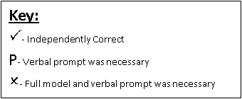

Progress Monitoring
I will administer three-minute probes containing story starters at least three times a week until the students meet the performance objective listed below. I will then graph each probe data and will begin to apply curriculum based measurements (CBM) decision rules as soon as I have five sets of data. (Adapted from ED 3230 lesson plan)
CBM Performance Objective
Give a three-minute probe containing of a story starter, see page 13 for an example, and the directions listed on the probe, the student will write correct word sequences based on the norms published by Malecki & Jewell (2003) for three consecutive probes, using different story starts each time.

Planning Compare/Contrast Writing
Steps:
- Write the two or more items being compared/ contrasted.
- Write three or more characteristics that are common to the items being compared/ contrasted.
Characteristic- a feature, property, quality, or trait of both items.
- For each characteristic, list ways the items are alike.
- Then, for each characteristic, list ways the two items were different.
- Repeat steps 3 and 4 until you have listed the similarities and differences for all of your characteristics.
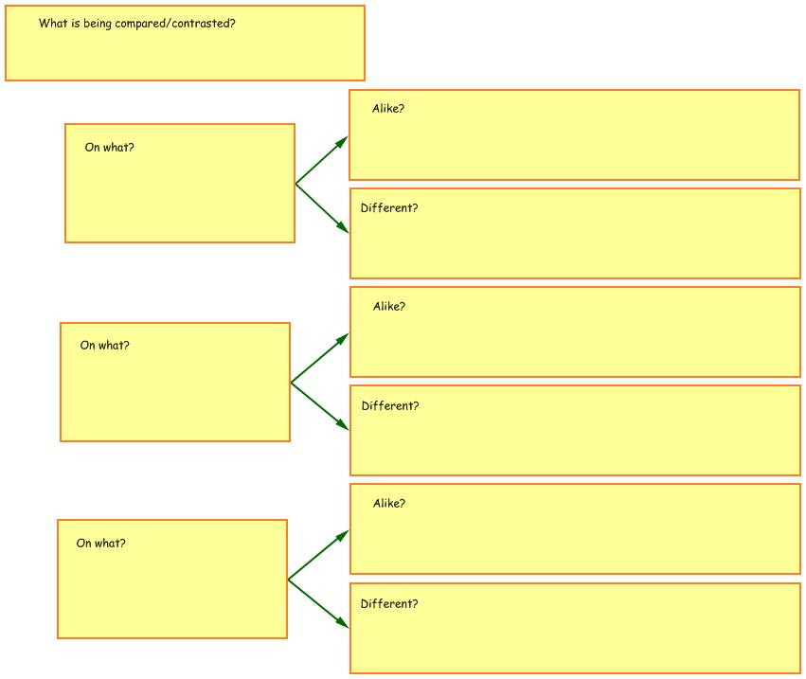
Name ____________________________ | Date _________________________

What Do We Have In Common?
Directions: For each number, explain what the words have in common.

1. California, New York, Mississippi | _________________________________________
2. Pizza, French fries, Cheeseburger | _________________________________________
3. Rose, Daffodil, Carnation | _________________________________________
4. Washington, Lincoln, Clinton | _________________________________________
5. Red, Blue, Purple | _________________________________________
6. Radio, Telephone, CD player | _________________________________________
7. Milk, Juice, Soda pop | _________________________________________
8. Basketball, Football, Soccer | _________________________________________
9. Newspaper, Book, Magazine | _________________________________________
10. Cow, Pig, Horse | _________________________________________
11. Thanksgiving, Christmas, Easter | _________________________________________
12. Computer, Television, Movies | _________________________________________
13. Eyes, Nose, Mouth | _________________________________________
14. Fork, Spoon, Knife | _________________________________________
15. Math, Social Studies, Science | _________________________________________

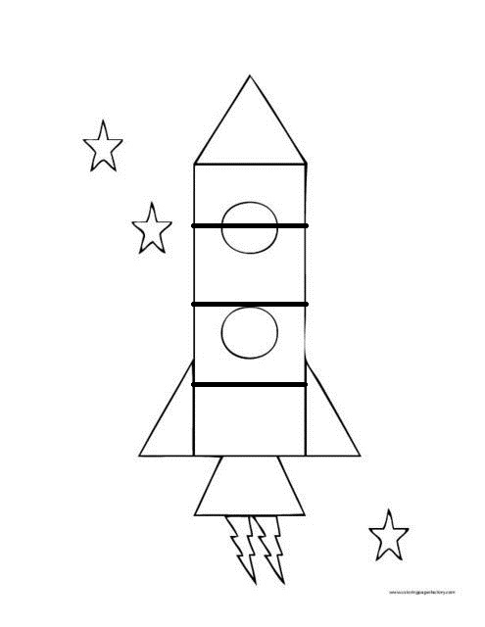
Story Starters:
1. Currently, students attend school five days a week, and have off for summer vacation. Many people believe it should be change so children attend school all year round. I believe this shouldn’t be changed because…
2. The basketball player triend to throw the ball toward the hoop but instead the ball sailed high overhead and…

